INNOVATION
ISOM DIGIWARE: new insulation control system for IT systems

Benfeld, March 2019

Introducing ISOM Digiware, Socomec's innovative 2 in 1 system that combines insulation and power monitoring for IT systems.
This interconnected system instantly detects and pinpoints any insulation fault. It guarantees continuity of service even for first insulation faults, while protecting people and property.

ISOM Digiware is a solution designed for various applications including industrial, marine, petrochemical, energy production, civil engineering and healthcare.

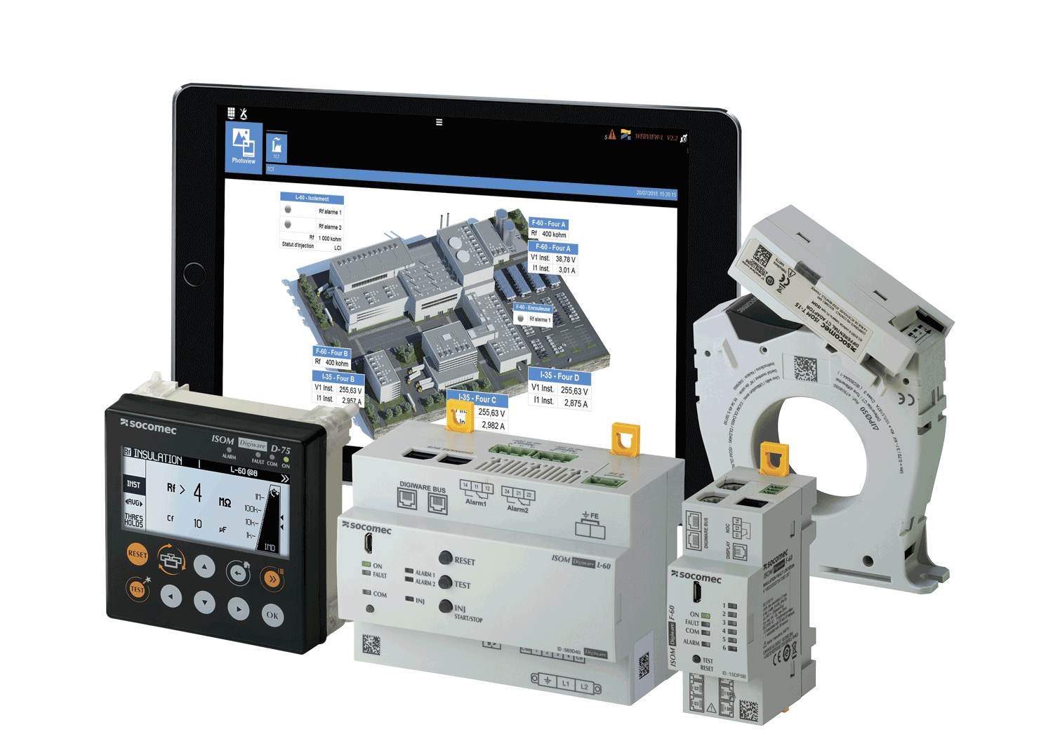
The key features behind the system's success:
- It groups the 2 functions of monitoring insulation and power monitoring.
- The power and simplicity of the Digiware system: flexibility, scalability, quick installation.
- Technological performance: predictive system.

Suitable for new and existing systems, the ISOM Digiware system integrates various add-ons:
- ISOM Digiware D displays: single access point for measurement and alert data.
- The optional DIRIS Digiware U voltage acquisition module: accesses energy and power measuring functions.
- The ISOM Digiware L-60 module for insulation monitoring and fault locating signal injection: monitors the networks' degree of insulation.
- The ISOM Digiware F-60 insulation fault location and power monitoring module: measures both the insulation and load current (up to 6 inputs).
- Locating core balance transformers: quickly pin-point the faulty circuit in the cabinet.
- TE, TR, TF current sensors: measure the current load of an electrical system.

OhmScanner solution: insulation mapping for predictive maintenance
This system tracks the overall insulation of the system and automatically triggers a regular and detailed mapping of the insulation at every key circuit.
- Predictive system: detects insulation degradations and anticipates real insulation faults.
- Mapping of the insulation.
- Continuous monitoring of the insulation level of each circuit.
- Simultaneously analyses insulation and monitoring parameters to identify correlations and clarify the source of faults.

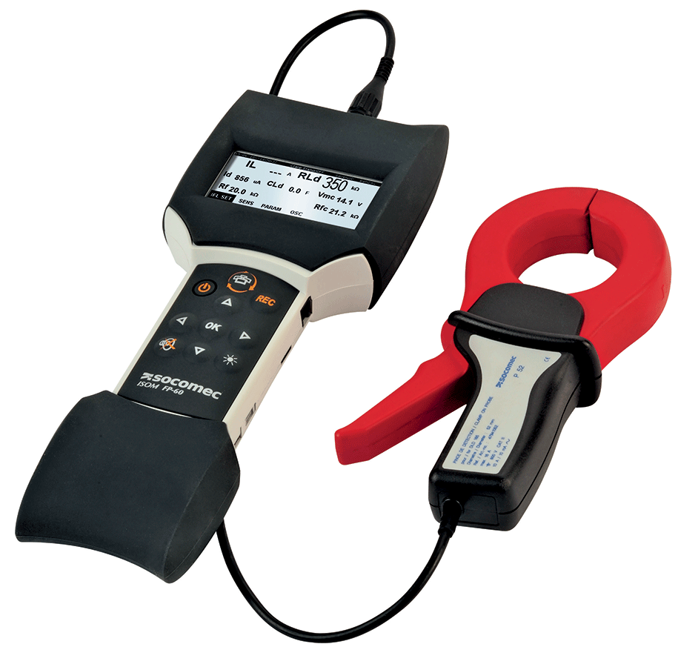
ISOM FP-60: portable insulation fault location system
With its insulation measurement mode and its oscilloscope-type display, ISOM FP-60 is the tool for tracking insulation faults at the furthest points of the electrical installation.

All our solutions include the WEBVIEW software that lets you show and use measurement data remotely and in realtime.

ABOUT SOCOMEC |  | FOR MORE INFORMATION
Founded in 1922, SOCOMEC is an industrial group with a workforce of over 3,200 people around the world in 27 subsidiaries. Our core business: the availability, control and safety of low voltage electrical networks… with increased focus on our customers' power performance. In 2017, SOCOMEC posted turnover of €505 million. |  | Press contact:  Virginie GUYOT  Offer Communication Manager  Tel. : +33 (0)3 88 57 78 15  Email : virginie.presse@socomec.com  www.socomec.fr

